Hubert Jakubiak
Nr. Indeksu: 50985
ZUT Wydział Informatyczny w Szczecinie
Drugi rok akademicki

Sprawozdanie
Zarządzanie informacją 1
Laboratorium 2

Zajęcia odbyły się: 17.03.2023
- Punkt:
Komenda SQL:
INSERT INTO `jh50985`.`products` (
`code_product` ,
`product_Name` ,
`description` ,
`details` ,
`amount` ,
`price`
)
VALUES
('2', 'Monitor LCD 19"', NULL , NULL , '5', '250.00'),
('3', 'Monitor LCD 29"', NULL , NULL , '15', '550.00'),
('4', 'Monitor LCD 19"', NULL , NULL , '30', '300.00'),
('5', 'Monitor LCD 21"', NULL , NULL , '25', '250.00'),
('6', 'klawiatura', NULL , NULL , '15', '67.45'),
('7', 'plyta glowna', NULL , NULL , '20', '350.20'),
('8', 'klawiatura', NULL , NULL , '35', '42.35'),
('9', 'mysz bezprzewodowa', NULL , NULL , '23', '51.00'),
('10', 'pamiec SSD', NULL , NULL , '50', '75.25');

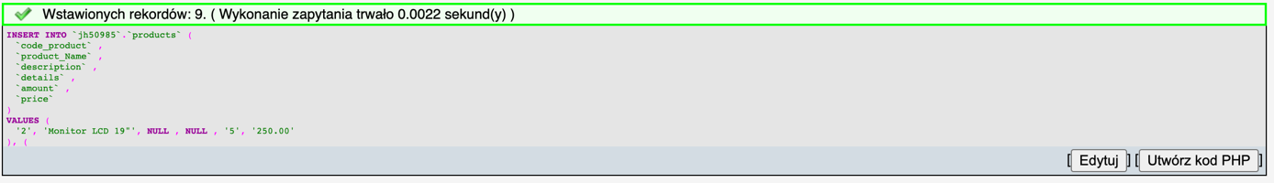

- Punkt:
Komenda SQL:
A)
ALTER TABLE `jh50985`.`products` ADD COLUMN `manufaktor` VARCHAR(20) NULL

ALTER TABLE `jh50985`.`products` ADD COLUMN `model` VARCHAR(20) NULL

B)
ALTER TABLE `jh50985`.`products` CHANGE `manufaktor` `manufaktor` VARCHAR(30)

C)
UPDATE `jh50985`.`products` SET `model`='NC125',`manufaktor`='Toshiba' WHERE `code_product`=1;
UPDATE `jh50985`.`products` SET `model`='',`manufaktor`='Linea' WHERE `code_product`=2;
UPDATE `jh50985`.`products` SET `model`='MBE1234',`manufaktor`='Belinea' WHERE `code_product`=3;
UPDATE `jh50985`.`products` SET `model`='',`manufaktor`='Sharp' WHERE `code_product`=4;
UPDATE `jh50985`.`products` SET `model`='',`manufaktor`='Sharp' WHERE `code_product`=5;
UPDATE `jh50985`.`products` SET `model`='model',`manufaktor`='producent' WHERE `code_product`=6;
UPDATE `jh50985`.`products` SET `model`='',`manufaktor`='Assus' WHERE `code_product`=7;
UPDATE `jh50985`.`products` SET `model`='BKE12',`manufaktor`='Logitech' WHERE `code_product`=8;
UPDATE `jh50985`.`products` SET `model`='',`manufaktor`='AITECH' WHERE `code_product`=9;
UPDATE `jh50985`.`products` SET `model`='OWE12',`manufaktor`='BIGComp' WHERE `code_product`=10;

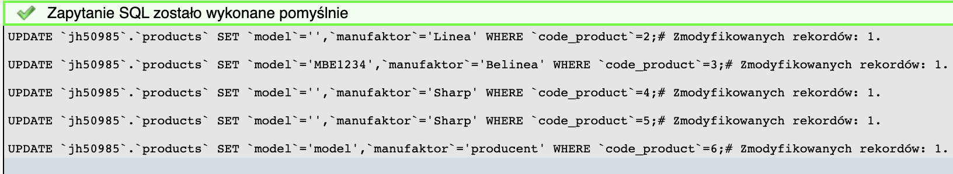

- Punkt:
Komenda SQL:
UPDATE `jh50985`.`products` SET `manufaktor`='Sony' WHERE `manufaktor`='producent'
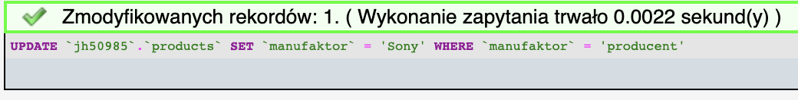
UPDATE `jh50985`.`products` SET `model`='Nowy' WHERE `model`='NULL'
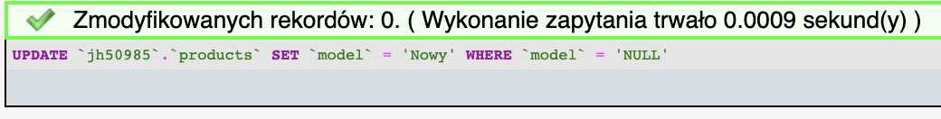
UPDATE `jh50985`.`products` SET `manufaktor`='Pro' WHERE `manufaktor`='AITECH';
UPDATE `jh50985`.`products` SET `model`='Pro' WHERE `model`='model' ;
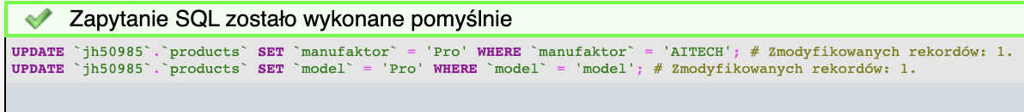

- Punkt:
Komenda SQL:
ALTER TABLE `jh50985`.`products` DROP COLUMN `model`
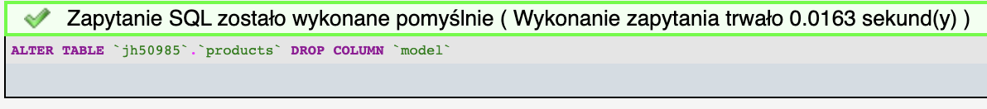

- Punkt:
Komenda SQL:
A)
DELETE FROM `jh50985`.`products` WHERE `amount`<10
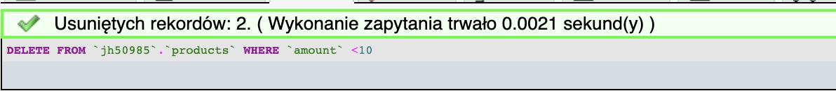

B)
DELETE FROM `jh50985`.`products` WHERE `product_Name` LIKE "%klawiatura%"
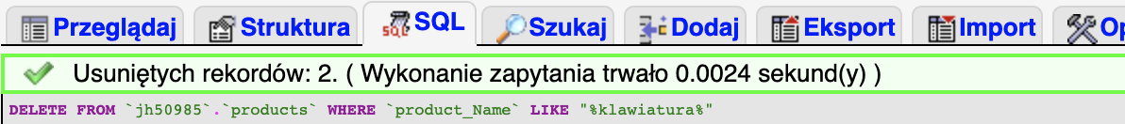

C)
DELETE FROM `jh50985`.`products` WHERE `price` BETWEEN 200 AND 300
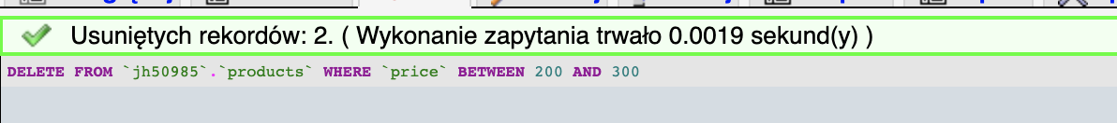

- Punkt:
Komenda SQL:
TRUNCATE TABLE `products`
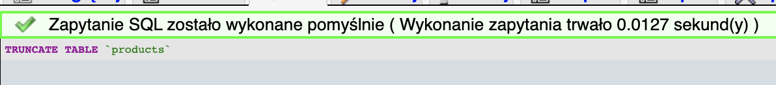

- Punkt:
Komenda SQL:
DROP TABLE `products`
